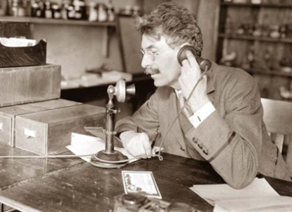 | 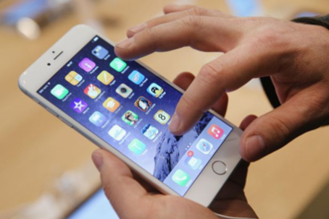 | 
Verleden tijd | Tegenwoordige tijd | Toekomst
PAST | Present | Future
Past Simple | Present Simple | Will/ Shall
Present Perfect | Present Continuous | Going to

 | Past Simple  Ik werkte |  |  | Present Perfect  Ik heb gewerkt
When | Duidelijk wanneer het gebeurd is |  |  | Onduidelijk wanneer het gebeurd is
Rule | ww + ed |  |  | Have/ has + ww + ed
Uitzonderingen  op de regel | Irregular verbs (onregelmatige ww.) zijn allemaal verschillend en moet je uit je hoofd leren. Degene die je moet kennen staan op de volgende bladzijde.
How I | worked |  |  | have worked
You | worked |  |  | have worked
She / He / It | worked |  |  | has worked
We | worked |  |  | have worked
They | worked |  |  | have worked
Indicator | - Yesterday |  |  | - For
 | - In 1983 |  |  | - Yet
 | - Last week |  |  | - Never
 | - Three days ago |  |  | - Ever
 | - A minute ago |  |  | - Just
 | - When I was young |  |  | - Already
 |  |  |  | - Since
 |  |  |  | - Once
 |  |  |  | - Recently
Nederlands |  | Tegenwoordige tijd  Present simple | Verleden tijd  Past simple |  | Voltooid deelwoord  Present perfect
Zijn/ Worden |  | Be | Was/ Were |  | Been
Brengen |  | Bring | Brought |  | Brought
Kopen |  | Buy | Bought |  | Bought
Kiezen |  | Choose | Chose |  | Chosen
Komen |  | Come | Came |  | Come
Doen |  | Do | Did |  | Done
Drinken |  | Drink | Drank |  | Drunk
Eten |  | Eat | Ate |  | Eaten
Voeren |  | Feed | Fed |  | Fed
Vergeten |  | Forget | Forgot |  | Forgotten
Krijgen/ Worden |  | Get | Got |  | Got
Geven |  | Give | Gave |  | Given
Gaan |  | Go | Went |  | Gone
Hebben |  | Have | Had |  | Had
Horen |  | Hear | Heard |  | Heard
Verlaten |  | Leave | Left |  | Left
Verliezen |  | Loose | Lost |  | Lost
Maken |  | Make | Made |  | Made
Ontmoeten |  | Meet | Met |  | Met
Betalen |  | Pay | Paid |  | Paid
Lezen |  | Read | Read |  | Read
Zeggen |  | Say | Said |  | Said
Zien |  | See | Saw |  | Seen
Slapen |  | Sleep | Slept |  | Slept
Spreken |  | Speak | Spoke |  | Spoken
Uitgeven/ Doorbrengen |  | Spend | Spent |  | Spent
Nemen/ Brengen |  | Take | Took |  | Taken
Denken |  | Think | Thought |  | Thought
Kleding dragen |  | Wear | Wore |  | Worn
Schrijven |  | Write | Wrote |  | Written
Past Simple

- Listen to story and underline all the verbs in the past tense. The first one is given.

My Daughter Learned to Count
My daughter woke me around 11:50 last night. My husband and I had picked her up earlier from her friend Sally's birthday party, brought her home, and put her to bed. My husband went into the bedroom to read while I fell asleep watching the Braves game.
" Mommy," she whispered, tugging my shirt sleeve. "Guess how old I'm going to be next month."
"I don't know, beauty," I said as I slipped on my glasses. "How old?"
She smiled and held up four fingers.
It is 7:30 now. My husband and I have been up with her for almost 8 hours. She still refuses to tell us where she got those fingers.

- Read the story again and circle the irregular verbs in the past tense.

- Past simple regular verbs: in each sentence underscore the indicator and fill the gap with the correct form of the past simple verb.
- Last year Naomi and Nina (crash) crashed a party because it sounded awesome.
- Dennis (walk) ______________________________ the dog yesterday.
- Columbus (sail) ______________________________ to America in 1492.
- She (play) ______________________________ the piano when she was young.

- Past simple irregular verbs: in each sentence underscore the indicator and fill the gap with the correct form of the past simple verb.
- When I was five years old I (eat) ate an apple each day.
- Last weekend Elke (come) ______________________home in the middle of the night .
- We (see) ______________________________a good film last week.
- She (have) ______________________________a headache yesterday.

- Mixed exercises: past simple regular and irregular.
- We (cross) ______________________________the Channel when we (go) ______________________________on holiday to England last summer.
- (Do) ______________________________ you have a bicycle when you (be) ______________________________ young?
- When we (arrive) ______________________________ at the airport I (realise) ______________________________ that I (forget) ______________________________ to bring my passport.

Present perfect

- Present perfect regular verbs: fill the gap with the correct form of the past simple verb.
- I (walk) have walked in the snow once.
- She (learn) ______________________________ for the test.
- The package (arrive) ______________________________ through the chimney.
- They (develop) ______________________________ a cure for being stupid, hooray!

- Present perfect irregular verbs: fill the gap with the correct form of the past simple verb.
- I (speak) have spoken to the boss.
- He (pay) ______________________________ for the drinks.
- We (make) ______________________________ a giant stone turtle.
- Sinterklaas and Piet (hear) ______________________________ everything.

- Mixed exercises: present perfect regular and irregular.
- They (work) ___________________ very hard to help you.
- The rain (stop) ______________________________ , thank god.
- I (make) ______________________________ a mistake.

Past Simple & Present perfect

- LEVEL3 and LEVEL 4 STUDENTS.
Super mega mix of the previous exercises. Fill the gap with the correct form of the verb. This could be either the Past Simple or the Present Perfect. And the verbs could be either regular or irregular.
- Bart (prune) ______________________________ the rose bushes for ages, however at four ‘o clock his boss (say) ______________________________ he wasn’t done yet.
- She (adopt) ______________________________ a dog last year and (be) ______________________________ training him ever since.
- I (break) ___________________ the window but luckily nobody (see) ___________________ it when it happened.
- You (loose) ___________________ your mind if you think I would (loan) ___________________ him my car just like that.
- Bassie and Adriaan (scream) ___________________ with laughter after the Baron (explode) ___________________ into a million pieces when he sat on that bomb.

